

# INTRODUCTION

* 1. Overview

In this project, we use custom objects, relationships, page layouts to give the HR team easy access to data they need on an existing recruitment app.

* 1. Purpose

To make the existing app more efficient for the HR team we create custom objects and relationships to store and access the data more efficiently. We install an unmanaged package in the org to get metadata that acts as existing data in the recruitment app.

1. **Problem Definition & Design Thinking**
   1. Empathy Map

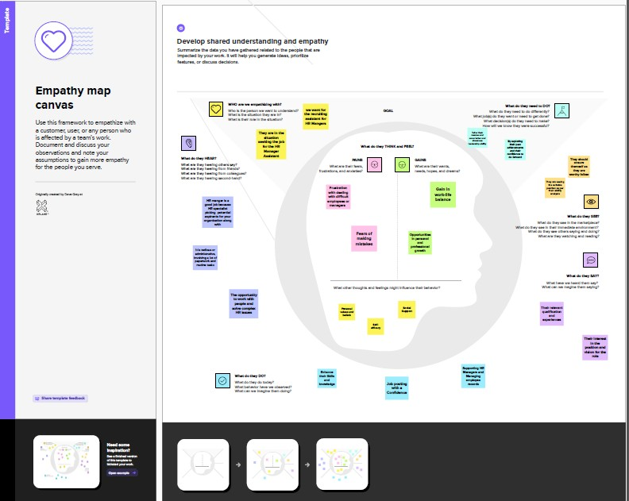

* 1. 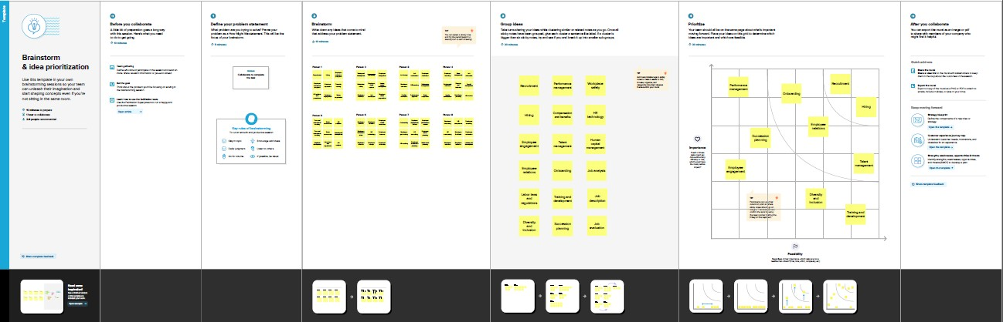Ideation & Brainstorming Map

# RESULT

* 1. Data Model:

|  |  |  |  |  |
| --- | --- | --- | --- | --- |
| **Object name** | **Fields in the Object** | | | |
| Job Posting Site |  | | | |
|  | Field label | Data type |  |
| Job posting site | URL |
| Status | URL |
| Technical site | URL |
| Description | URL |
|  | | | |
| Job Posting |  | | | |
|  | Field label | Data type |  |
| Job posting | Auto Number |
| Job posting | Master-detail relationship |
| Job posting | Master-detail relationship |
|  | | | |

# Activity & Screenshot Activity 1- Object Creation

**JOB POSTING SITE**

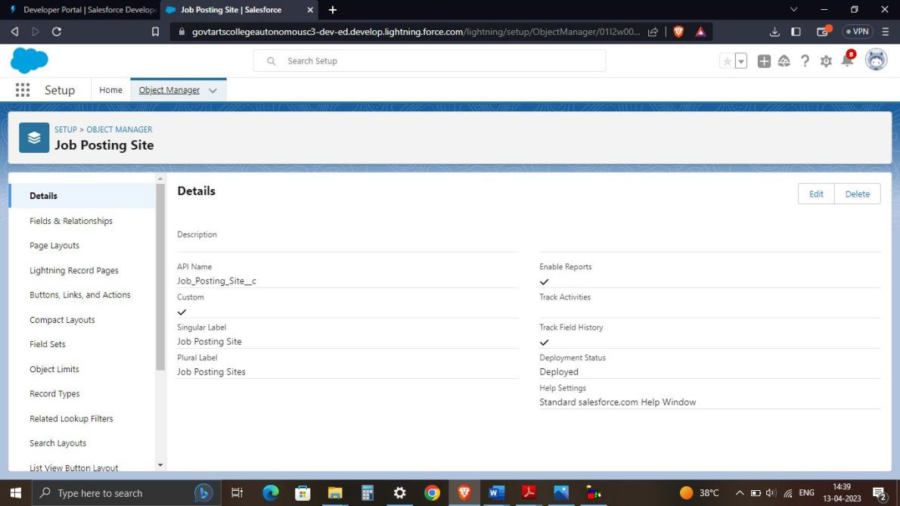We created a custom object for Job Posting Sites

# REVIEW

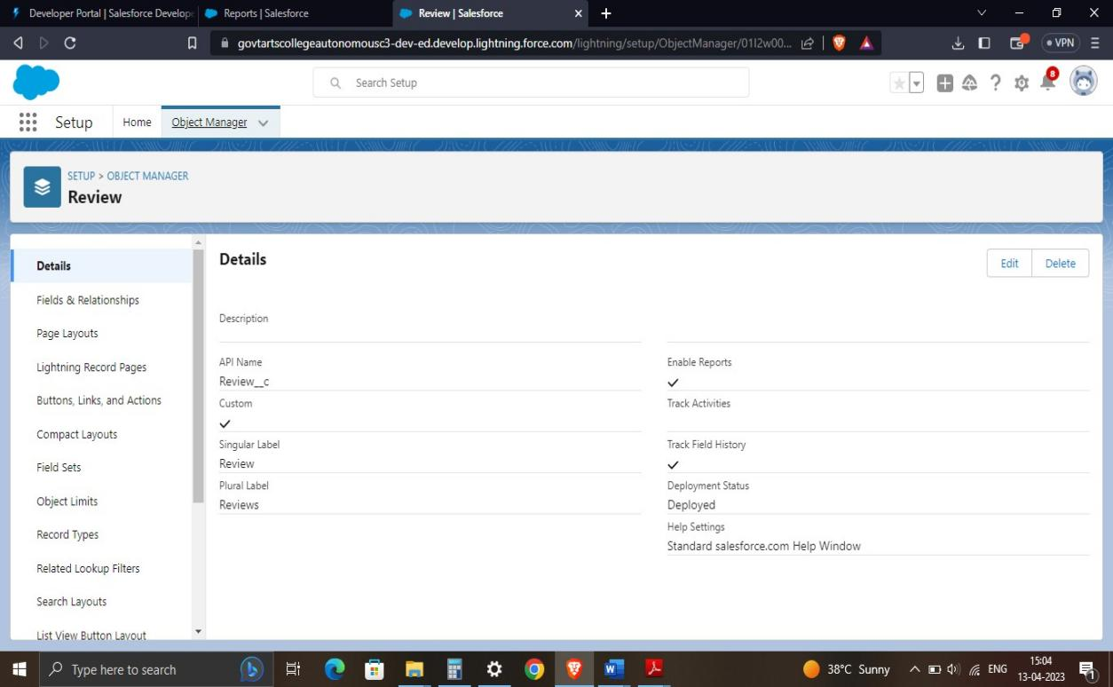

We created a custom object for Review

# Activity 2- Tabs

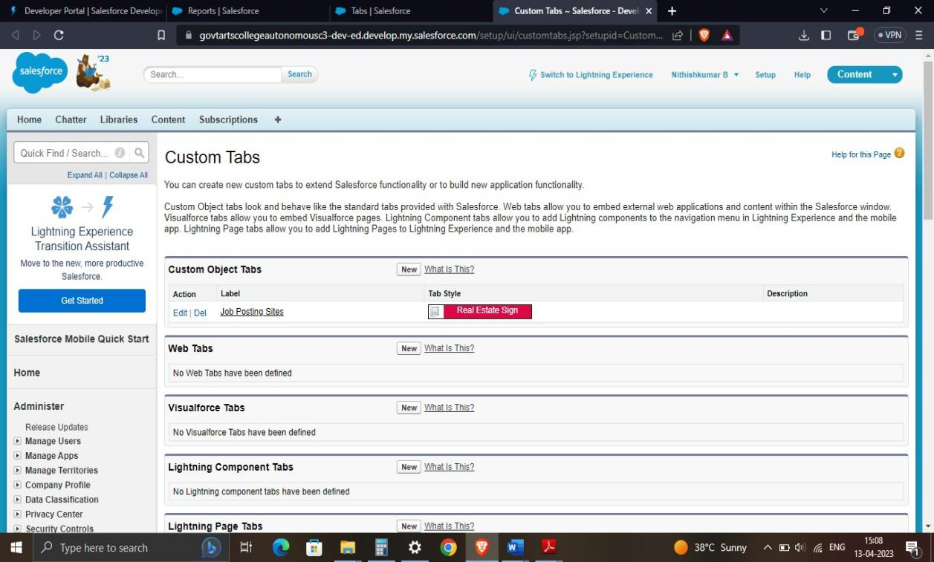

we customized the look of the Job posting site object's tab

# Activity 3 – Fields

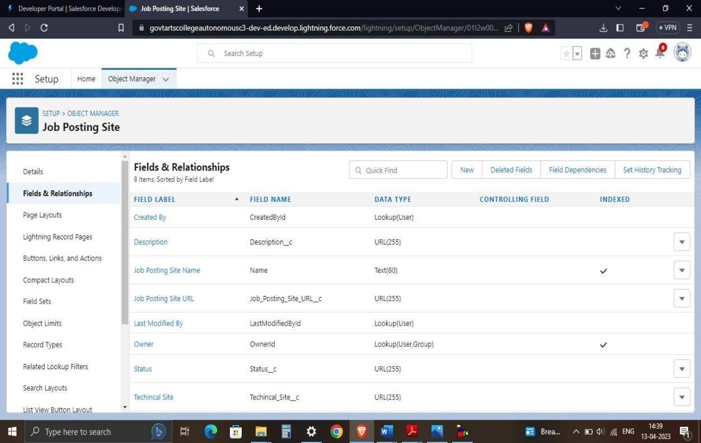**JOB POSTING SITE**

We created a fields for Job Posting Site

# Activity 4 – Junction Object

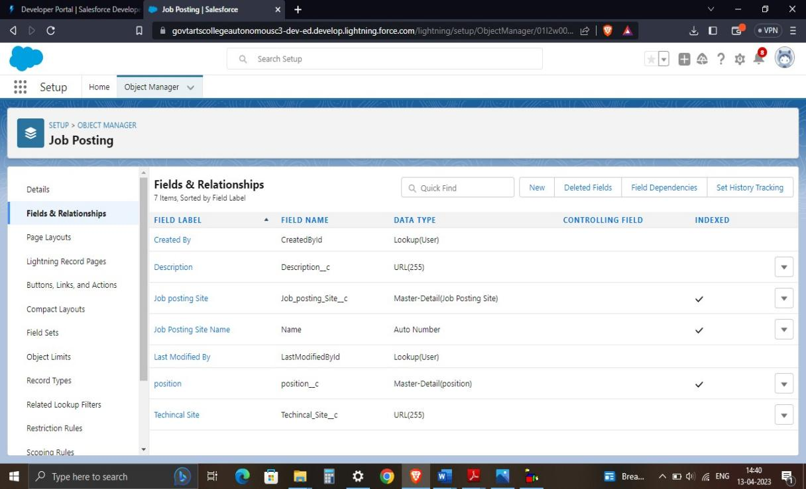

We created a master-detail relationship between Job posting and job posting site and also position

# Activity 5 – Page Layout

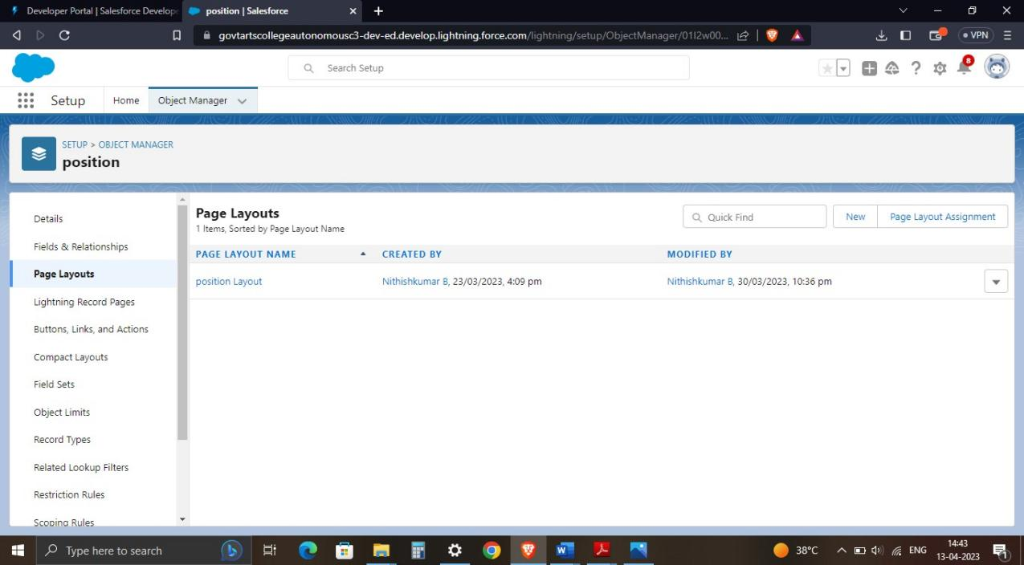

We modified the page layout for Job Posting Site and Review

# Activity 6 – Validation Rules

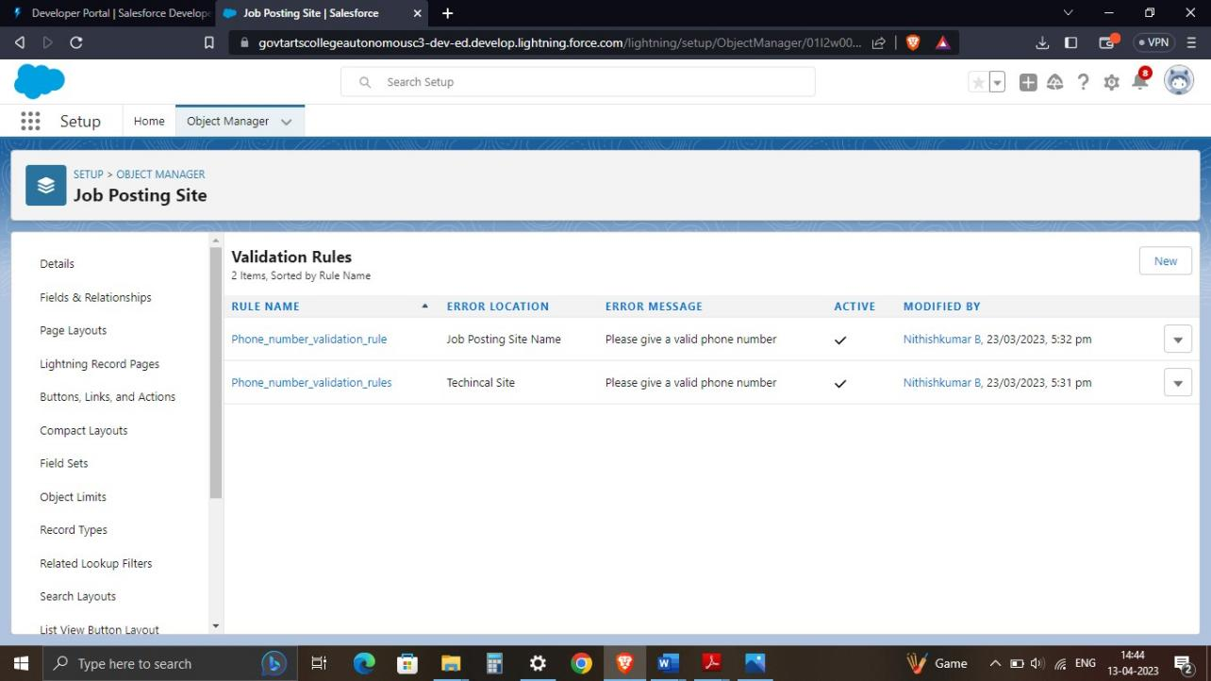

We created a validation rule for checking the phone number is in 10 digits

# Activity 7 – Profile

We created a Profile and it can be assigned to many users, but user can be assigned single profile at a time.

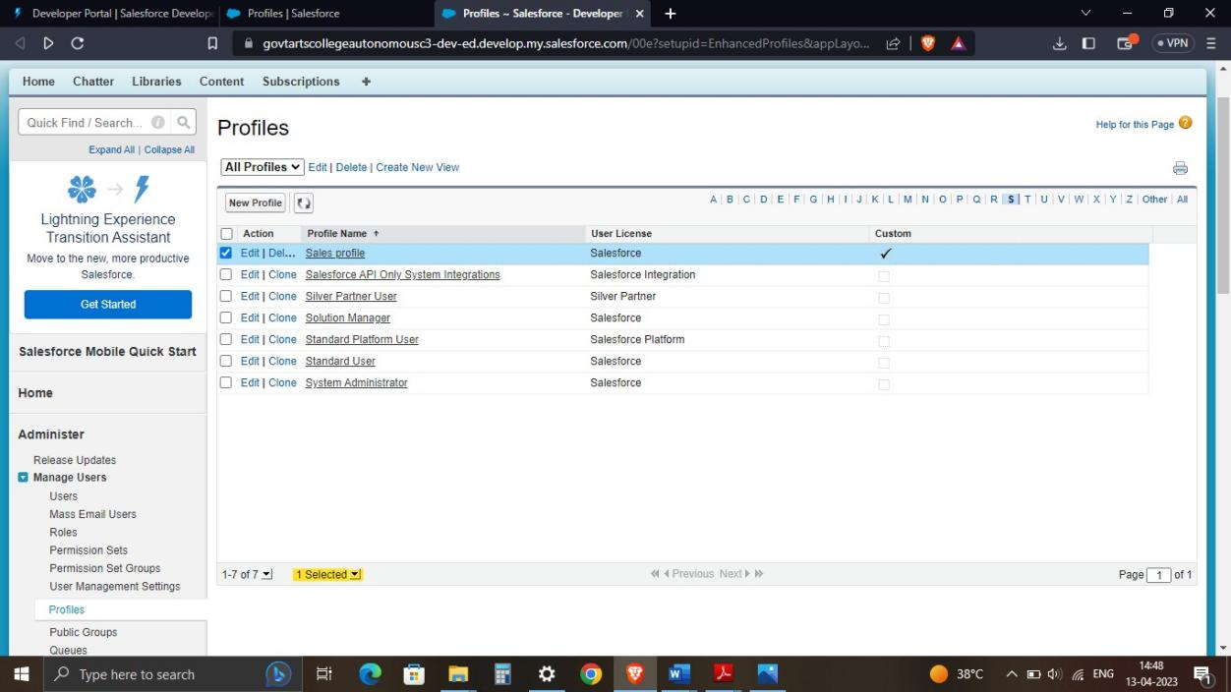

# Activity 8 – User

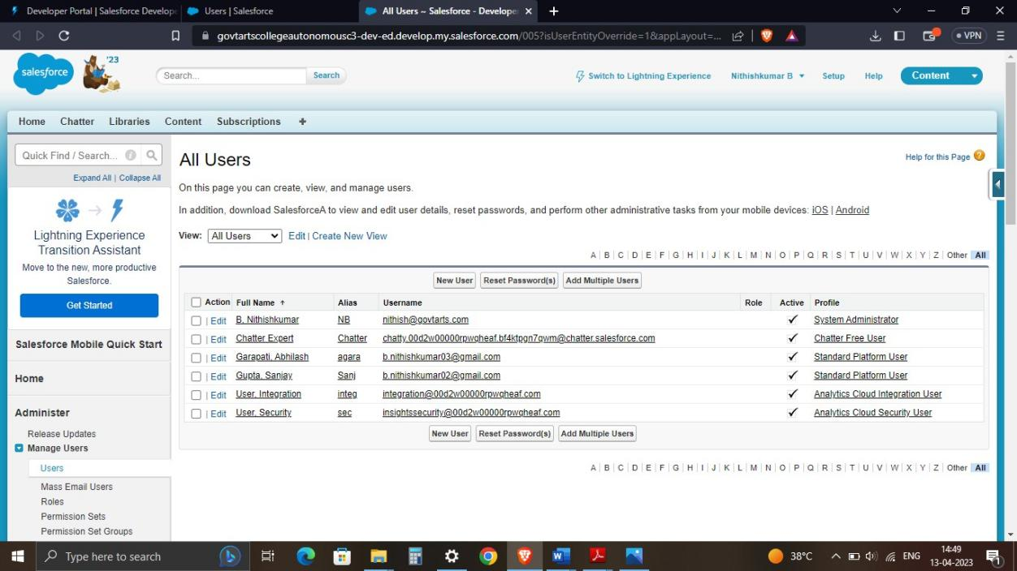

We created a user and users are employees at your company, such as sales representative, managers, and IT specialists, who need access to

the company's records

# Activity 9 – Permission Set

We created a Permission Set and it is a collection of settings and permissions that give users access to various tools and functionality in

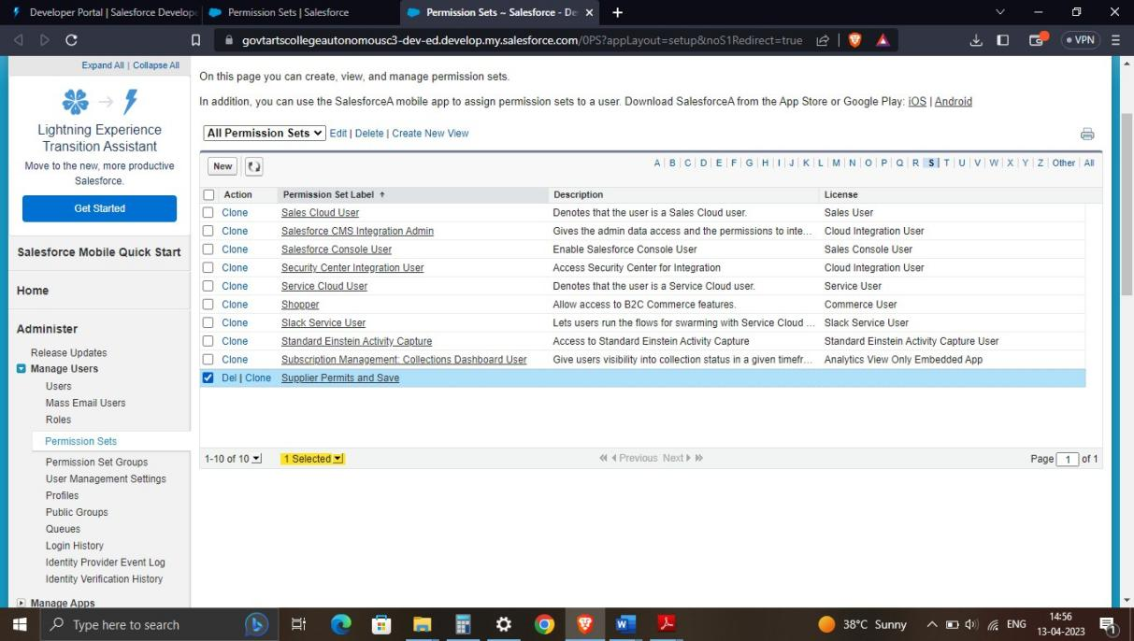

the platform

# Activity 10 – Reports

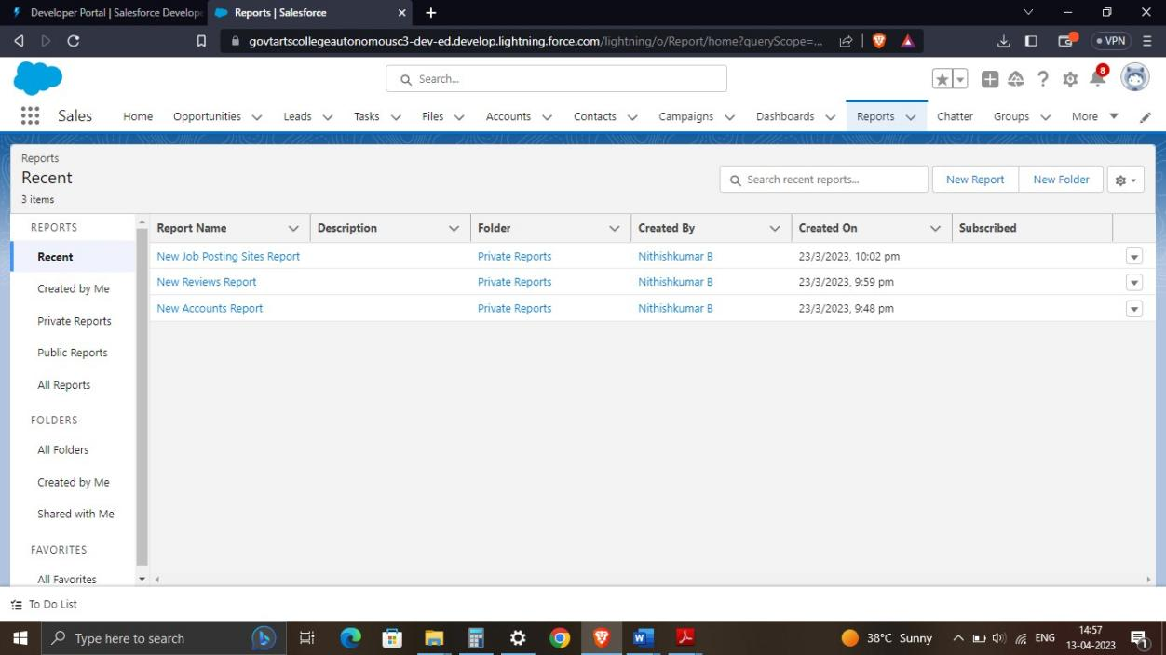

We generated a report for review and Job Posting Objects.



# Trailhead Profile Public URL

# SUGANTH K (Team Lead )-

[https://trailblazer.me/id](https://trailblazer.me/id/nithb14)/suganth

**ASHOK R-**

[https://trailblazer.me/id/](https://trailblazer.me/id/djaganathan1)ashor95

**HIRUTHICK KANTHAN M-**

[https://trailblazer.me/id/](https://trailblazer.me/id/mugis2)hiruthickkanthanvd7

# SOUNDARYA G- [https://trailblazer.me/id/](https://trailblazer.me/id/mugis2)soundarya-20112003



1. **ADVANTAGES**

* HR managers are trained and experienced in recruitment processes, and they have the necessary skills to identify and hire the right candidates. They can leverage their knowledge to help the organization attract and retain the best talent.
* HR managers have experience in managing employee relations, which can help reduce conflicts and maintain a positive work environment. They can provide advice to managers and employees, resolve disputes, and ensure employees are treated fairly
* HR managers can develop and implement training programs to improve employee skills and performance, which can lead to increased productivity, job satisfaction, and retention.

# DISADVANTAGES

* Recruiting and hiring a skilled HR manager can be expensive. Depending on the organization's size, the HR manager's salary and benefits package may be a significant cost.
* HR managers typically focus on HR-related activities, which may not align with the organization's overall business strategy. This can lead to a narrow focus on HR-related issues, rather than considering the organization's broader goals.
* HR managers may resist change or be slow to adopt new HR practices, which can limit the organization's ability to innovate and adapt to changing business conditions.

# APPLICATIONS

HR managers can help identify and recruit the best candidates for the Salesforce course. They can review resumes, conduct interviews, and assess candidates' skills and qualifications to ensure that the organization hires the right people. HR managers can provide guidance and support to employees in the Salesforce course, addressing any issues related to

performance, workplace conflicts, or career development. They can also foster a positive work environment that promotes employee engagement, productivity, and retention. HR managers can develop and implement training programs for employees in the Salesforce course, ensuring they have the necessary skills and knowledge to perform their job duties effectively. This can lead to improved employee performance, job satisfaction, and retention. HR managers can ensure that the Salesforce course complies with employment laws and regulations, such as EEOC, FLSA, and OSHA. They can also develop policies and procedures that adhere to legal requirements and mitigate the risk of legal issues or fines. HR managers can contribute to the organization's strategic planning process by identifying workforce needs, creating talent acquisition plans, and developing HR policies that align with the organization's goals. This can help ensure that the Salesforce course has the necessary resources and talent to achieve its objectives.

# CONCLUSION

Recruiting an HR manager can provide numerous advantages for an organization, including improved recruitment and hiring practices, employee relations, training and development, compliance with employment laws, and strategic planning. While there may be some potential disadvantages, such as cost or limited experience in other areas, these can be mitigated by selecting a skilled and experienced HR manager with a broad understanding of the organization's goals and objectives. Overall, an HR manager can play a critical role in supporting an organization's growth and success by fostering a positive work environment, developing employee skills and knowledge, and aligning HR policies with the overall business strategy.

# FUTURE SCOPE

Recruiting an HR Manager can provide numerous benefits to an organization, not only in the present but also in the future. As businesses continue to evolve, the role of HR will become even more critical, and the need for skilled and experienced HR professionals will only increase. With the increasing competition for talent, HR managers will play a critical role in identifying and recruiting the best candidates for various roles in the

organization. They will use advanced tools and technologies to source, screen and assess candidates, while also promoting the company's brand as an employer of choice. With the advancements in AI and machine learning, HR managers can leverage these technologies to streamline HR processes, automate repetitive tasks, and provide more data-driven insights. This will allow HR managers to focus on more strategic initiatives, such as talent management and employee development. In the future, diversity and inclusion will be a critical aspect of HR management. HR managers will be responsible for creating a culture of inclusion, promoting diversity in the workplace, and ensuring that all employees feel valued and respected. They will also be responsible for addressing unconscious bias and implementing initiatives to attract and retain a diverse workforce. With the rise of the gig economy and the changing expectations of employees, HR managers will need to focus on creating a positive employee experience. This will involve offering flexible work arrangements, personalized learning and development opportunities, and a culture that promotes work-life balance and well-being.